Jade Pearl
COSC 320-001 Lab 09: Graph 4/23/2023

Lab report: I authorize that what was done in this lab is my own work. I reached out to Olivia Brague (classmate) for some help when I got stuck. I finished this lab in approximately 1.5 hours.

Pre-lab:
- Understand what we learned about graph in class and read related book materials
- Read and understand given file d_graph.h
- Create data file graphA.dat for given graphA. Format for the data file is given in graph.dat where m is # of vertices in graph, n is # edges, weight_i is the weight of edge from source_i to destination_i. graphA.dat will be used for the lab

Files Created:
lab_09.cpp,

Lab 8
Exercise 1: Copy needed files to working directory
Exercise 2: Write lab_09.cpp; it inputs the data for graph A then carry out tasks:
Insert an edge from F to D with weight 1
Delete vertex B
Erase the edge (A,D)
Prompt user to input vertex and list all the neighbors of the vertex
Insert new vertex G
Add following edges with weight 1: (G,C), (G,F), (D,G)
Output the graph using operator <<
Source Code:
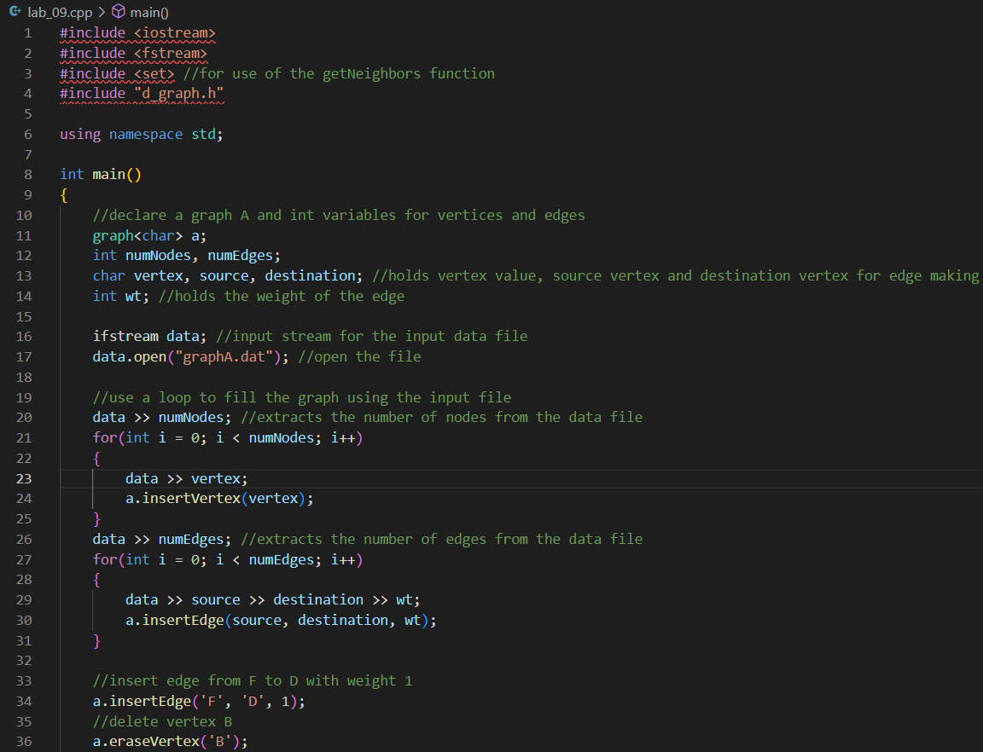
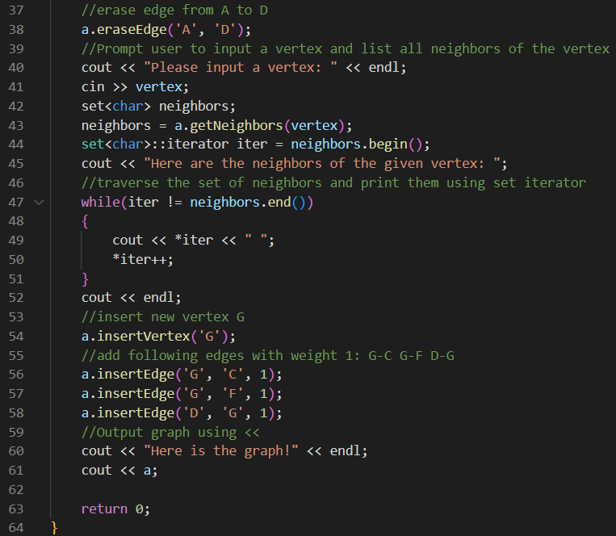

Sample Outputs:
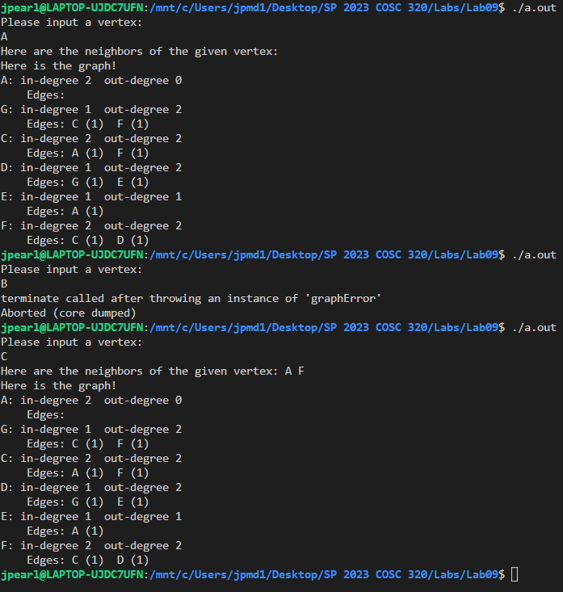
Note: In the code, vertex B is deleted before asking the user for a vertex so that is why there is a graph error that kicks out of the program. In that case, the user is asking for a vertex that does not exist.

